Project Design Phase
Problem – Solution Fit Template
Date | 06 October 2026
Team ID | SWTID-2026-9105
Project Name | Implement Client Script & UI Policy (Incident)
Maximum Marks | 2 Marks
Problem – Solution Fit: ServiceNow Incident
The Problem–Solution Fit for this project connects the Incident data-entry and control problem with a practical ServiceNow solution. UI Policies, UI Policy Actions, and Client Scripts are used to control conditional field behaviour, automate updates, validate submissions, and prevent inappropriate list editing.
Purpose:
❑ Solve the Incident data-quality problem through controls that fit the user's workflow.
❑ Improve solution adoption by using the existing ServiceNow Incident form and list.
❑ Provide clear triggers, field behaviour, and validation feedback at the point of entry.
❑ Reduce frequent errors caused by missing information or uncontrolled field changes.
❑ Understand the existing Incident-entry situation and improve it for the target user.
Project Problem–Solution Fit Canvas
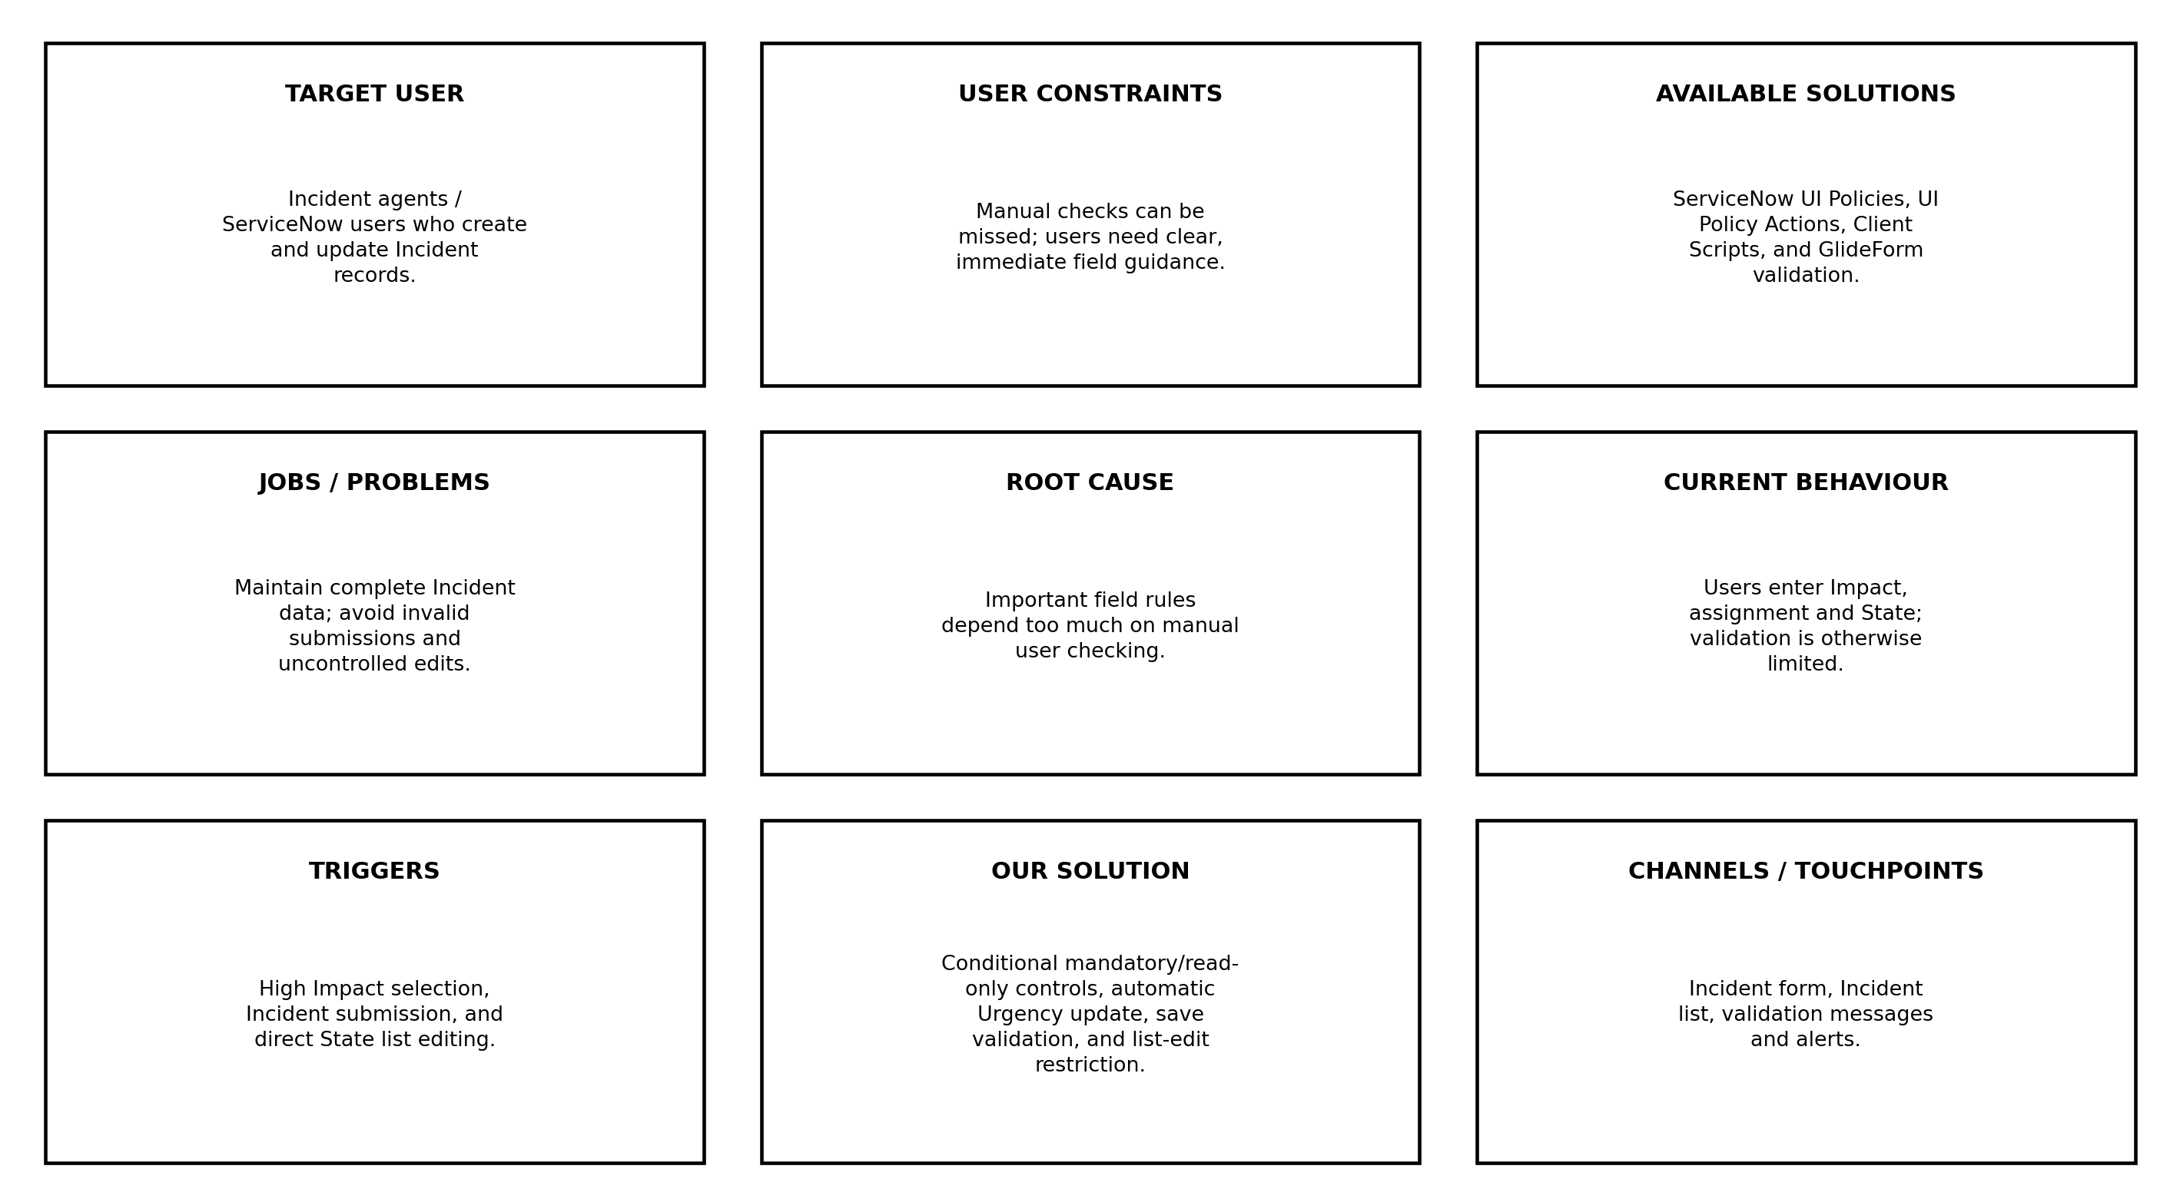

References
1. Problem–Solution Fit Canvas template supplied in the project documentation.
2. Project basis: Implement Client Script & UI Policy (Incident) implementation and testing.
3. ServiceNow Incident configuration: UI Policy, UI Policy Actions, onChange, onSubmit, and onCellEdit Client Scripts.
Solution Mapping
Problem Area | ServiceNow Control | Expected Benefit
Incomplete assignment information | UI Policy + onSubmit validation | Prevents invalid High Impact submissions
Manual Urgency update | onChange Client Script | Automatically sets Urgency to High
Uncontrolled State list editing | onCellEdit Client Script | Blocks direct State changes from list editing
Changing conditions | Reverse-if-false UI Policy | Restores normal field behaviour
Problem–Solution Fit | Implement Client Script & UI Policy (Incident)

